UNIVERSITY OF ENGINEERING AND TECHNOLOGY

(NAROWAL CAMPUS)



# Object-Oriented Programming Lab Manual

Created by: Muhammad Abdullah

Registration Number: 2022-CS-525

Topics: Installation of Visual Studio

Lab Manual

(Object-Oriented Programming Lab)

* **Visual Studio:**

Visual Studio is an integrated development environment (IDE) from Microsoft. It is used to develop computer programs including websites, web apps, web services, and mobile apps. Visual Studio uses Microsoft software development platforms such as Windows API, Windows Forms, Windows Presentation Foundation, Windows Store, and Microsoft Silverlight. It can produce both native code and managed code.

Visual Studio includes a code editor supporting IntelliSense (the code completion component) as well as code refactoring. The integrated debugger works as both a source-level debugger and a machine-level debugger. Other built-in tools include a code profiler, a designer for building GUI applications, a web designer, a class designer, and a database schema designer. It accepts plug-ins that expand the functionality at almost every level—including adding support for source control systems (like Subversion and Git) and adding new toolsets like editors and visual designers for domain-specific languages or toolsets for other aspects of the software development lifecycle (like the Azure DevOps client: Team Explorer).

Visual Studio supports 36 different programming languages and allows the code editor and debugger to support (to varying degrees) nearly any programming language, provided a language-specific service exists. Built-in languages include C, C++, C++/CLI, Visual Basic .NET, C#, F#, JavaScript, TypeScript, XML, XSLT, HTML, and CSS. Support for other languages such as Python, Ruby, Node.js, and M among others is available via plug-ins. Java (and J#) were supported in the past.

The most basic edition of Visual Studio, the Community edition, is available free of charge. The Visual Studio Community edition slogan is "Free, fully-featured IDE for students, open-source and individual developers".

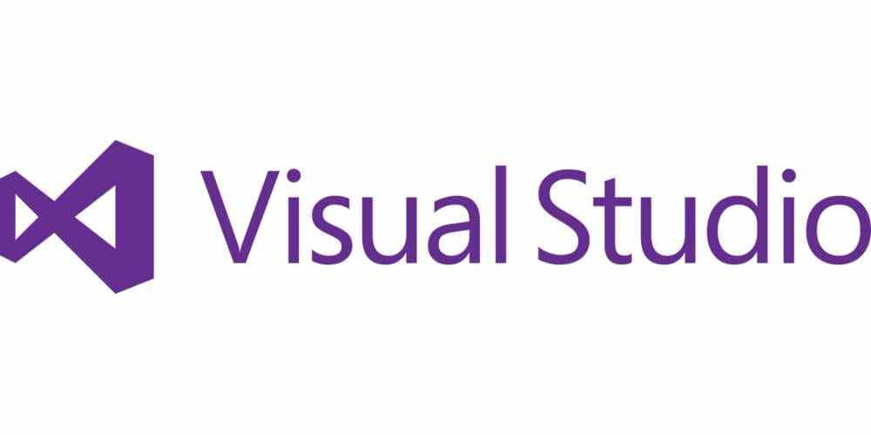

Installation Procedure: